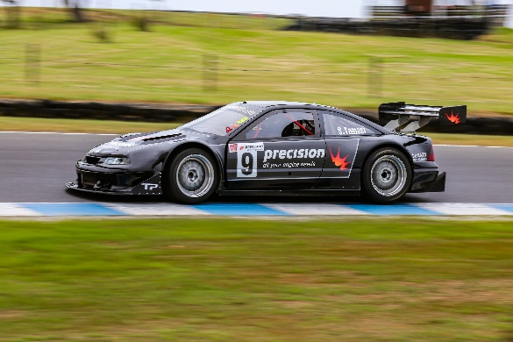

National Australian Sports Sedan Association Inc.

Phil Crompton (Secretary/Treasurer)
11 Winchcombe Avenue, Murrumba Downs Qld 4503
Phones: 07 3886 0930 (H) 0411 740092 (M)
Email: crompo57@bigpond.com

27/01/2022

Dear National Series Competitor

Membership fees are due to rejoin/join NASSA Inc. for the 2022 calendar year.

NASSA Inc. membership is required to participate in any round of the National Series other than state events held in conjunction with a national round in your home state.

NASSA is a Motorsport Australia affiliated club and our membership card is accepted as an approved card when entering Motorsport Australia race events.

NASSA also has a representative on the National Sports Sedan Committee therefore has a valuable vote on the Group 3D technical regulation amendments, along with the various state associations.

An invoice is under separate attachment and is payable unless the National Series management have included same in your series registration payment.

Enjoy your year and best wishes in achieving your goals.

Phil Crompton

